# Office AMS: SharePoint bulk DOCUMENT UPLOADER

|  |  |
| --- | --- |
| Summary: | Applies to: |
| This sample shows how to bulk upload documents into a target site collection within SPO using the C# REST API | * Office 365 Multi Tenant (MT) * Office 365 Dedicated (D) * SharePoint 2013 on-premises |
| Solution: | Core.BulkDocumentUploader, version 1.0 |
| Author: | Luke Bailey (Microsoft) |
| //*********************************************************  // THIS CODE IS PROVIDED *AS IS* WITHOUT WARRANTY OF  // ANY KIND, EITHER EXPRESS OR IMPLIED, INCLUDING ANY  // IMPLIED WARRANTIES OF FITNESS FOR A PARTICULAR  // PURPOSE, MERCHANTABILITY, OR NON-INFRINGEMENT.  //********************************************************* | |

# Overview

This sample code and documentation presents an automated way of uploading documents to a targetted site collection through the REST C# API as is a typical request during O365 migrations, for example uploading company policies to each users OneDrive or an index of their migrated content.

# Scenario 1: bulk UPLOADING DOCUMENTS TO ONEDRIVE

The single input file to the utility is **OneDriveUploader.xml** which defines the profile property mappings and connection details for the entire utility. The two primary root elements for the file are <loggers> and <actions>:

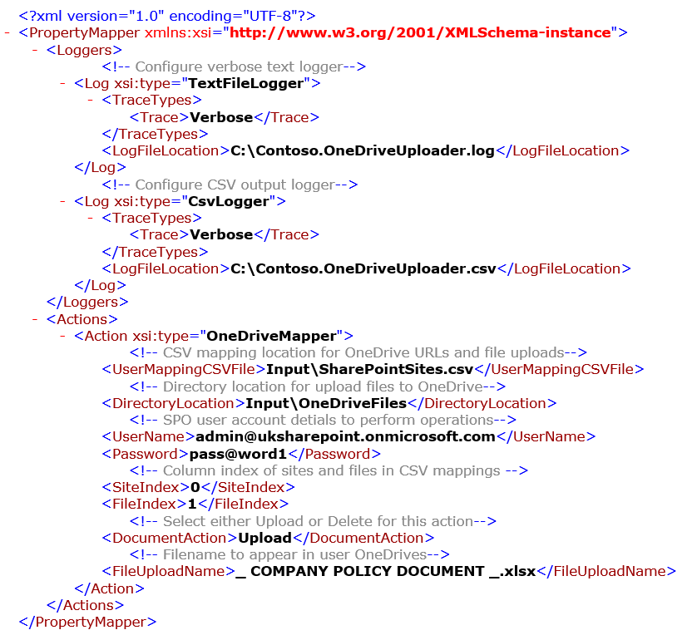

|  |  |  |
| --- | --- | --- |
| Parent Element | Child Element | Value and Description |
| TraceTypes | Trace | Ability to define level of logging for the current logging object.  **Values**: Error, Verbose |
| LogFileLocation | n/a | TextFileLogger and CsvLogger specific attribute that governs where the output file will be written to |

* + 1. Action Elements

|  |  |  |
| --- | --- | --- |
| Parent Element | Child Element | Value and Description |
| UserMappingCSVFile | n/a | Defines the location of the CSV containing the target sites and the filename to be uploaded |
| DirectoryLocation | n/a | The folder containing the actual files to be uploaded that map to the CSV files entries. |
| UserName | n/a | A dedicated O365 service account created to run the utility that is a global administrator |
| Password | n/a | Corresponding O365 user account password |
| SiteIndex | n/a | The column index of the target sites in the CSV file |
| FileIndex | n/a | The column index of the target filenames in the CSV file |
| DocumentAction | n/a | Whether the files are to be uploaded or deleted from the target site collection |
| FileUploadName | n/a | Attribute to allow the files to be renamed to something approraite to the content such as company policy. |

**Running the application**

Navigate to the directory of the **Contoso.BulkDocumentUploader.exe**, the executable requires a single input parameter which is the ContosoOneDriveUploader.xml